**Build the best network using Keras**

Using Keras, we are trying to build the convolution neural network. We are running the model with different parameters such as number of neurons, number of epochs, learning rate, batch size etc. for tiny imagenet dataset. We are giving input image of size 32*32. Below are the different experiments we tried:

**Experiment 1:**

No of epochs: 5

Batch size: 100

Number of Conv layers: 9

Learning rate:0.0001

Optimizer: SGD

Activation functions: relu

Dropout rates: 0.25

rain on 100000 samples, validate on 10000 samples

Epoch 1/5

100000/100000 [==============================] - 71s 709us/step - loss: 12.2756 - acc: 0.0049 - val_loss: 7.7419 - val_acc: 0.0050

Epoch 2/5

100000/100000 [==============================] - 65s 645us/step - loss: 11.4799 - acc: 0.0051 - val_loss: 6.7344 - val_acc: 0.0050

Epoch 3/5

100000/100000 [==============================] - 65s 646us/step - loss: 11.1058 - acc: 0.0050 - val_loss: 6.3346 - val_acc: 0.0050

Epoch 4/5

100000/100000 [==============================] - 64s 642us/step - loss: 10.9032 - acc: 0.0051 - val_loss: 6.2376 - val_acc: 0.0050

Epoch 5/5

100000/100000 [==============================] - 64s 644us/step - loss: 10.8934 - acc: 0.0052 - val_loss: 6.2157 - val_acc: 0.0050

Test loss: 6.215653311157227

Test accuracy: 0.005

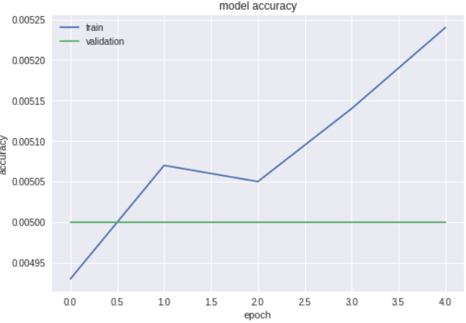

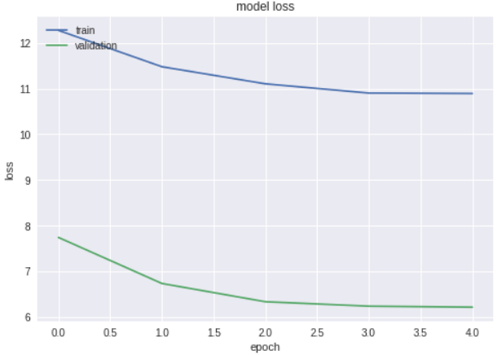

**Experiment 2:**

No of epochs: 5

Batch size: 100

Number of Conv layers: 3

Learning rate:0.0001

Optimizer: SGD

Activation functions: relu

Dropout rates: 0.25

Train on 100000 samples, validate on 10000 samples

Epoch 1/5

100000/100000 [==============================] - 9s 89us/step - loss: 10.3822 - acc: 0.0048 - val_loss: 5.2995 - val_acc: 0.0046

Epoch 2/5

100000/100000 [==============================] - 8s 85us/step - loss: 10.3652 - acc: 0.0051 - val_loss: 5.2994 - val_acc: 0.0047

Epoch 3/5

100000/100000 [==============================] - 8s 85us/step - loss: 10.3557 - acc: 0.0050 - val_loss: 5.2993 - val_acc: 0.0047

Epoch 4/5

100000/100000 [==============================] - 8s 85us/step - loss: 10.3338 - acc: 0.0052 - val_loss: 5.2992 - val_acc: 0.0047

Epoch 5/5

100000/100000 [==============================] - 8s 85us/step - loss: 10.3664 - acc: 0.0052 - val_loss: 5.2991 - val_acc: 0.0048

10000/10000 [==============================] - 1s 84us/step

Test loss: 5.299073176574707

Test accuracy: 0.0048

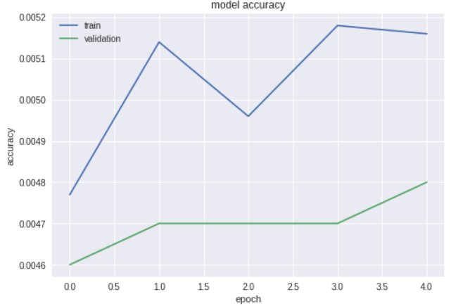

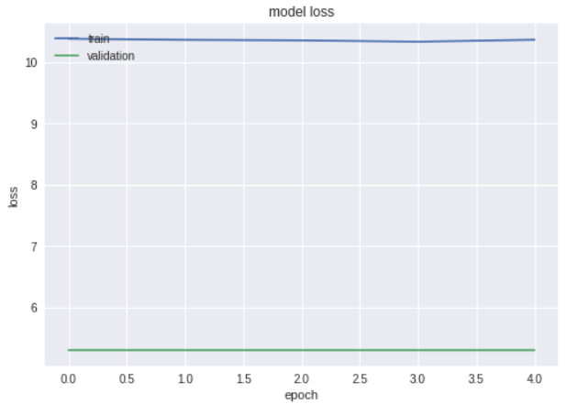

**Experiment 3:**

No of epochs: 50

Batch size: 100

Number of Conv layers: 7

Learning rate:0.0001

Optimizer: SGD

Activation functions: relu

Dropout rates: 0.25

Train on 100000 samples, validate on 10000 samples

Epoch 1/50

100000/100000 [==============================] - 57s 574us/step - loss: 5.2983 - acc: 0.0050 - val_loss: 5.2983 - val_acc: 0.0042

Epoch 2/50

100000/100000 [==============================] - 48s 476us/step - loss: 5.2983 - acc: 0.0048 - val_loss: 5.2983 - val_acc: 0.0042

Epoch 3/50

100000/100000 [==============================] - 52s 522us/step - loss: 5.2983 - acc: 0.0049 - val_loss: 5.2983 - val_acc: 0.0042

Epoch 4/50

100000/100000 [==============================] - 52s 518us/step - loss: 5.2983 - acc: 0.0050 - val_loss: 5.2983 - val_acc: 0.0041

Epoch 5/50

100000/100000 [==============================] - 51s 512us/step - loss: 5.2983 - acc: 0.0051 - val_loss: 5.2983 - val_acc: 0.0041

Epoch 6/50

100000/100000 [==============================] - 52s 519us/step - loss: 5.2983 - acc: 0.0046 - val_loss: 5.2983 - val_acc: 0.0041

Epoch 7/50

100000/100000 [==============================] - 52s 521us/step - loss: 5.2983 - acc: 0.0054 - val_loss: 5.2983 - val_acc: 0.0041

Epoch 8/50

100000/100000 [==============================] - 52s 522us/step - loss: 5.2983 - acc: 0.0050 - val_loss: 5.2983 - val_acc: 0.0041

Epoch 9/50

100000/100000 [==============================] - 52s 520us/step - loss: 5.2983 - acc: 0.0052 - val_loss: 5.2983 - val_acc: 0.0039

Epoch 10/50

100000/100000 [==============================] - 52s 520us/step - loss: 5.2983 - acc: 0.0049 - val_loss: 5.2983 - val_acc: 0.0041

Epoch 11/50

100000/100000 [==============================] - 52s 520us/step - loss: 5.2983 - acc: 0.0049 - val_loss: 5.2983 - val_acc: 0.0041

Epoch 12/50

100000/100000 [==============================] - 52s 519us/step - loss: 5.2983 - acc: 0.0051 - val_loss: 5.2983 - val_acc: 0.0044

Epoch 13/50

100000/100000 [==============================] - 52s 516us/step - loss: 5.2983 - acc: 0.0049 - val_loss: 5.2983 - val_acc: 0.0044

Epoch 14/50

100000/100000 [==============================] - 52s 520us/step - loss: 5.2983 - acc: 0.0048 - val_loss: 5.2983 - val_acc: 0.0044

Epoch 15/50

100000/100000 [==============================] - 52s 519us/step - loss: 5.2983 - acc: 0.0050 - val_loss: 5.2983 - val_acc: 0.0045

Epoch 16/50

100000/100000 [==============================] - 52s 517us/step - loss: 5.2983 - acc: 0.0052 - val_loss: 5.2983 - val_acc: 0.0045

Epoch 17/50

100000/100000 [==============================] - 52s 518us/step - loss: 5.2983 - acc: 0.0054 - val_loss: 5.2983 - val_acc: 0.0046

Epoch 18/50

100000/100000 [==============================] - 52s 521us/step - loss: 5.2983 - acc: 0.0051 - val_loss: 5.2983 - val_acc: 0.0047

Epoch 19/50

100000/100000 [==============================] - 52s 522us/step - loss: 5.2983 - acc: 0.0053 - val_loss: 5.2983 - val_acc: 0.0048

Epoch 20/50

100000/100000 [==============================] - 52s 522us/step - loss: 5.2983 - acc: 0.0051 - val_loss: 5.2983 - val_acc: 0.0044

Epoch 21/50

100000/100000 [==============================] - 52s 520us/step - loss: 5.2983 - acc: 0.0050 - val_loss: 5.2983 - val_acc: 0.0045

Epoch 22/50

100000/100000 [==============================] - 52s 521us/step - loss: 5.2983 - acc: 0.0051 - val_loss: 5.2983 - val_acc: 0.0046

Epoch 23/50

100000/100000 [==============================] - 52s 519us/step - loss: 5.2983 - acc: 0.0052 - val_loss: 5.2983 - val_acc: 0.0048

Epoch 24/50

100000/100000 [==============================] - 52s 516us/step - loss: 5.2983 - acc: 0.0054 - val_loss: 5.2983 - val_acc: 0.0048

Epoch 25/50

100000/100000 [==============================] - 52s 519us/step - loss: 5.2983 - acc: 0.0048 - val_loss: 5.2983 - val_acc: 0.0047

Epoch 26/50

100000/100000 [==============================] - 52s 522us/step - loss: 5.2983 - acc: 0.0053 - val_loss: 5.2983 - val_acc: 0.0048

Epoch 27/50

100000/100000 [==============================] - 52s 522us/step - loss: 5.2983 - acc: 0.0048 - val_loss: 5.2983 - val_acc: 0.0048

Epoch 28/50

100000/100000 [==============================] - 52s 520us/step - loss: 5.2983 - acc: 0.0049 - val_loss: 5.2983 - val_acc: 0.0050

Epoch 29/50

100000/100000 [==============================] - 52s 522us/step - loss: 5.2983 - acc: 0.0050 - val_loss: 5.2983 - val_acc: 0.0050

Epoch 30/50

100000/100000 [==============================] - 52s 520us/step - loss: 5.2983 - acc: 0.0049 - val_loss: 5.2983 - val_acc: 0.0052

Epoch 31/50

100000/100000 [==============================] - 52s 520us/step - loss: 5.2983 - acc: 0.0054 - val_loss: 5.2983 - val_acc: 0.0051

Epoch 32/50

100000/100000 [==============================] - 52s 522us/step - loss: 5.2983 - acc: 0.0048 - val_loss: 5.2983 - val_acc: 0.0051

Epoch 33/50

100000/100000 [==============================] - 52s 520us/step - loss: 5.2983 - acc: 0.0049 - val_loss: 5.2983 - val_acc: 0.0051

Epoch 34/50

100000/100000 [==============================] - 52s 520us/step - loss: 5.2983 - acc: 0.0051 - val_loss: 5.2983 - val_acc: 0.0050

Epoch 35/50

100000/100000 [==============================] - 52s 517us/step - loss: 5.2983 - acc: 0.0049 - val_loss: 5.2983 - val_acc: 0.0050

Epoch 36/50

100000/100000 [==============================] - 52s 520us/step - loss: 5.2983 - acc: 0.0052 - val_loss: 5.2983 - val_acc: 0.0050

Epoch 37/50

100000/100000 [==============================] - 52s 520us/step - loss: 5.2983 - acc: 0.0050 - val_loss: 5.2983 - val_acc: 0.0049

Epoch 38/50

100000/100000 [==============================] - 52s 520us/step - loss: 5.2983 - acc: 0.0056 - val_loss: 5.2983 - val_acc: 0.0050

Epoch 39/50

100000/100000 [==============================] - 52s 521us/step - loss: 5.2983 - acc: 0.0047 - val_loss: 5.2983 - val_acc: 0.0049

Epoch 40/50

100000/100000 [==============================] - 52s 521us/step - loss: 5.2983 - acc: 0.0051 - val_loss: 5.2983 - val_acc: 0.0048

Epoch 41/50

100000/100000 [==============================] - 52s 517us/step - loss: 5.2983 - acc: 0.0051 - val_loss: 5.2983 - val_acc: 0.0048

Epoch 42/50

100000/100000 [==============================] - 52s 517us/step - loss: 5.2983 - acc: 0.0053 - val_loss: 5.2983 - val_acc: 0.0048

Epoch 43/50

100000/100000 [==============================] - 52s 521us/step - loss: 5.2983 - acc: 0.0052 - val_loss: 5.2983 - val_acc: 0.0049

Epoch 44/50

100000/100000 [==============================] - 52s 518us/step - loss: 5.2983 - acc: 0.0049 - val_loss: 5.2983 - val_acc: 0.0049

Epoch 45/50

100000/100000 [==============================] - 52s 519us/step - loss: 5.2983 - acc: 0.0051 - val_loss: 5.2983 - val_acc: 0.0049

Epoch 46/50

100000/100000 [==============================] - 52s 520us/step - loss: 5.2983 - acc: 0.0055 - val_loss: 5.2982 - val_acc: 0.0048

Epoch 47/50

100000/100000 [==============================] - 52s 522us/step - loss: 5.2983 - acc: 0.0054 - val_loss: 5.2982 - val_acc: 0.0048

Epoch 48/50

100000/100000 [==============================] - 52s 524us/step - loss: 5.2983 - acc: 0.0049 - val_loss: 5.2982 - val_acc: 0.0049

Epoch 49/50

100000/100000 [==============================] - 52s 523us/step - loss: 5.2983 - acc: 0.0050 - val_loss: 5.2982 - val_acc: 0.0049

Epoch 50/50

100000/100000 [==============================] - 52s 522us/step - loss: 5.2983 - acc: 0.0054 - val_loss: 5.2982 - val_acc:

10000/10000 [==============================] - 2s 175us/step

Test loss: 5.2982432044982914

Test accuracy: 0.0049

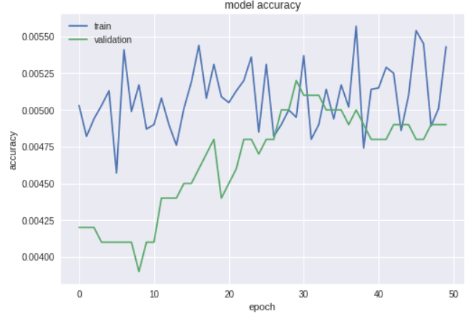

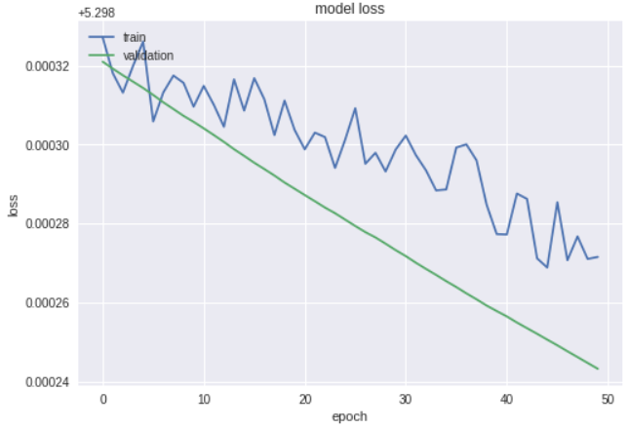

**Experiment 4:**

No of epochs: 100

Batch size: 100

Number of Conv layers: 7

Learning rate:0.0001

Optimizer: SGD

Activation functions: relu

Dropout rates: 0.25

Train on 100000 samples, validate on 10000 samples

Epoch 1/100

100000/100000 [==============================] - 51s 513us/step - loss: 5.2983 - acc: 0.0046 - val_loss: 5.2983 - val_acc: 0.0050

Epoch 2/100

100000/100000 [==============================] - 49s 489us/step - loss: 5.2983 - acc: 0.0047 - val_loss: 5.2983 - val_acc: 0.0050

Epoch 3/100

100000/100000 [==============================] - 49s 491us/step - loss: 5.2983 - acc: 0.0048 - val_loss: 5.2983 - val_acc: 0.0050

Epoch 4/100

100000/100000 [==============================] - 49s 493us/step - loss: 5.2983 - acc: 0.0048 - val_loss: 5.2983 - val_acc: 0.0050

Epoch 5/100

100000/100000 [==============================] - 49s 491us/step - loss: 5.2983 - acc: 0.0045 - val_loss: 5.2983 - val_acc: 0.0050

Epoch 6/100

100000/100000 [==============================] - 49s 493us/step - loss: 5.2983 - acc: 0.0046 - val_loss: 5.2983 - val_acc: 0.0050

Epoch 7/100

100000/100000 [==============================] - 49s 492us/step - loss: 5.2983 - acc: 0.0044 - val_loss: 5.2983 - val_acc: 0.0050

Epoch 8/100

100000/100000 [==============================] - 49s 493us/step - loss: 5.2983 - acc: 0.0046 - val_loss: 5.2983 - val_acc: 0.0050

Epoch 9/100

100000/100000 [==============================] - 49s 493us/step - loss: 5.2983 - acc: 0.0048 - val_loss: 5.2983 - val_acc: 0.0050

Epoch 10/100

100000/100000 [==============================] - 49s 493us/step - loss: 5.2983 - acc: 0.0046 - val_loss: 5.2983 - val_acc: 0.0050

Epoch 11/100

100000/100000 [==============================] - 49s 493us/step - loss: 5.2983 - acc: 0.0050 - val_loss: 5.2983 - val_acc: 0.0050

Epoch 12/100

100000/100000 [==============================] - 49s 493us/step - loss: 5.2983 - acc: 0.0046 - val_loss: 5.2983 - val_acc: 0.0050

Epoch 13/100

100000/100000 [==============================] - 49s 493us/step - loss: 5.2983 - acc: 0.0044 - val_loss: 5.2983 - val_acc: 0.0050

Epoch 14/100

100000/100000 [==============================] - 49s 490us/step - loss: 5.2983 - acc: 0.0046 - val_loss: 5.2983 - val_acc: 0.0050

Epoch 15/100

100000/100000 [==============================] - 49s 494us/step - loss: 5.2983 - acc: 0.0048 - val_loss: 5.2983 - val_acc: 0.0050

Epoch 16/100

100000/100000 [==============================] - 49s 491us/step - loss: 5.2983 - acc: 0.0048 - val_loss: 5.2983 - val_acc: 0.0050

Epoch 17/100

100000/100000 [==============================] - 49s 488us/step - loss: 5.2983 - acc: 0.0047 - val_loss: 5.2983 - val_acc: 0.0050

Epoch 18/100

100000/100000 [==============================] - 49s 490us/step - loss: 5.2983 - acc: 0.0049 - val_loss: 5.2983 - val_acc: 0.0050

Epoch 19/100

100000/100000 [==============================] - 49s 489us/step - loss: 5.2983 - acc: 0.0046 - val_loss: 5.2983 - val_acc: 0.0050

Epoch 20/100

100000/100000 [==============================] - 49s 490us/step - loss: 5.2983 - acc: 0.0043 - val_loss: 5.2983 - val_acc: 0.0050

Epoch 21/100

100000/100000 [==============================] - 49s 491us/step - loss: 5.2983 - acc: 0.0043 - val_loss: 5.2983 - val_acc: 0.0050

Epoch 22/100

100000/100000 [==============================] - 49s 491us/step - loss: 5.2983 - acc: 0.0049 - val_loss: 5.2983 - val_acc: 0.0050

Epoch 23/100

100000/100000 [==============================] - 49s 490us/step - loss: 5.2983 - acc: 0.0046 - val_loss: 5.2983 - val_acc: 0.0050

Epoch 24/100

100000/100000 [==============================] - 49s 489us/step - loss: 5.2983 - acc: 0.0047 - val_loss: 5.2983 - val_acc: 0.0050

Epoch 25/100

100000/100000 [==============================] - 49s 491us/step - loss: 5.2983 - acc: 0.0046 - val_loss: 5.2983 - val_acc: 0.0050

Epoch 26/100

100000/100000 [==============================] - 49s 490us/step - loss: 5.2983 - acc: 0.0052 - val_loss: 5.2983 - val_acc: 0.0050

Epoch 27/100

100000/100000 [==============================] - 49s 491us/step - loss: 5.2983 - acc: 0.0047 - val_loss: 5.2983 - val_acc: 0.0050

Epoch 28/100

100000/100000 [==============================] - 49s 491us/step - loss: 5.2983 - acc: 0.0046 - val_loss: 5.2983 - val_acc: 0.0050

Epoch 29/100

100000/100000 [==============================] - 49s 489us/step - loss: 5.2983 - acc: 0.0048 - val_loss: 5.2983 - val_acc: 0.0050

Epoch 30/100

100000/100000 [==============================] - 49s 489us/step - loss: 5.2983 - acc: 0.0044 - val_loss: 5.2983 - val_acc: 0.0050

Epoch 31/100

100000/100000 [==============================] - 49s 491us/step - loss: 5.2983 - acc: 0.0047 - val_loss: 5.2983 - val_acc: 0.0050

Epoch 32/100

100000/100000 [==============================] - 49s 491us/step - loss: 5.2983 - acc: 0.0049 - val_loss: 5.2983 - val_acc: 0.0050

Epoch 33/100

100000/100000 [==============================] - 49s 490us/step - loss: 5.2983 - acc: 0.0047 - val_loss: 5.2983 - val_acc: 0.0050

Epoch 34/100

100000/100000 [==============================] - 49s 488us/step - loss: 5.2983 - acc: 0.0044 - val_loss: 5.2983 - val_acc: 0.0050

Epoch 35/100

100000/100000 [==============================] - 49s 488us/step - loss: 5.2983 - acc: 0.0049 - val_loss: 5.2983 - val_acc: 0.0050

Epoch 36/100

100000/100000 [==============================] - 49s 486us/step - loss: 5.2983 - acc: 0.0049 - val_loss: 5.2983 - val_acc: 0.0050

Epoch 37/100

100000/100000 [==============================] - 49s 490us/step - loss: 5.2983 - acc: 0.0048 - val_loss: 5.2983 - val_acc: 0.0050

Epoch 38/100

100000/100000 [==============================] - 49s 490us/step - loss: 5.2983 - acc: 0.0045 - val_loss: 5.2983 - val_acc: 0.0050

Epoch 39/100

100000/100000 [==============================] - 49s 490us/step - loss: 5.2983 - acc: 0.0047 - val_loss: 5.2983 - val_acc: 0.0050

Epoch 40/100

100000/100000 [==============================] - 49s 491us/step - loss: 5.2983 - acc: 0.0047 - val_loss: 5.2983 - val_acc: 0.0050

Epoch 41/100

100000/100000 [==============================] - 49s 489us/step - loss: 5.2983 - acc: 0.0050 - val_loss: 5.2983 - val_acc: 0.0050

Epoch 42/100

100000/100000 [==============================] - 49s 488us/step - loss: 5.2983 - acc: 0.0046 - val_loss: 5.2983 - val_acc: 0.0050

Epoch 43/100

100000/100000 [==============================] - 49s 488us/step - loss: 5.2983 - acc: 0.0043 - val_loss: 5.2983 - val_acc: 0.0050

Epoch 44/100

100000/100000 [==============================] - 49s 489us/step - loss: 5.2983 - acc: 0.0049 - val_loss: 5.2983 - val_acc: 0.0050

Epoch 45/100

100000/100000 [==============================] - 49s 489us/step - loss: 5.2983 - acc: 0.0047 - val_loss: 5.2983 - val_acc: 0.0050

Epoch 46/100

100000/100000 [==============================] - 49s 490us/step - loss: 5.2983 - acc: 0.0051 - val_loss: 5.2983 - val_acc: 0.0050

Epoch 47/100

100000/100000 [==============================] - 49s 490us/step - loss: 5.2983 - acc: 0.0049 - val_loss: 5.2983 - val_acc: 0.0050

Epoch 48/100

100000/100000 [==============================] - 49s 488us/step - loss: 5.2983 - acc: 0.0050 - val_loss: 5.2983 - val_acc: 0.0050

Epoch 49/100

100000/100000 [==============================] - 49s 488us/step - loss: 5.2983 - acc: 0.0048 - val_loss: 5.2983 - val_acc: 0.0050

Epoch 50/100

100000/100000 [==============================] - 49s 491us/step - loss: 5.2983 - acc: 0.0046 - val_loss: 5.2983 - val_acc: 0.0050

Epoch 51/100

100000/100000 [==============================] - 49s 491us/step - loss: 5.2983 - acc: 0.0052 - val_loss: 5.2983 - val_acc: 0.0050

Epoch 52/100

100000/100000 [==============================] - 49s 490us/step - loss: 5.2983 - acc: 0.0049 - val_loss: 5.2983 - val_acc: 0.0050

Epoch 53/100

100000/100000 [==============================] - 49s 490us/step - loss: 5.2983 - acc: 0.0051 - val_loss: 5.2983 - val_acc: 0.0050

Epoch 54/100

100000/100000 [==============================] - 49s 490us/step - loss: 5.2983 - acc: 0.0046 - val_loss: 5.2983 - val_acc: 0.0050

Epoch 55/100

100000/100000 [==============================] - 49s 488us/step - loss: 5.2983 - acc: 0.0046 - val_loss: 5.2983 - val_acc: 0.0050

Epoch 56/100

100000/100000 [==============================] - 49s 489us/step - loss: 5.2983 - acc: 0.0045 - val_loss: 5.2983 - val_acc: 0.0050

Epoch 57/100

100000/100000 [==============================] - 49s 490us/step - loss: 5.2983 - acc: 0.0049 - val_loss: 5.2983 - val_acc: 0.0050

Epoch 58/100

100000/100000 [==============================] - 49s 489us/step - loss: 5.2983 - acc: 0.0045 - val_loss: 5.2983 - val_acc: 0.0050

Epoch 59/100

100000/100000 [==============================] - 49s 490us/step - loss: 5.2983 - acc: 0.0051 - val_loss: 5.2983 - val_acc: 0.0050

Epoch 60/100

100000/100000 [==============================] - 49s 490us/step - loss: 5.2983 - acc: 0.0051 - val_loss: 5.2983 - val_acc: 0.0050

Epoch 61/100

100000/100000 [==============================] - 49s 489us/step - loss: 5.2983 - acc: 0.0045 - val_loss: 5.2983 - val_acc: 0.0050

Epoch 62/100

100000/100000 [==============================] - 49s 489us/step - loss: 5.2983 - acc: 0.0045 - val_loss: 5.2983 - val_acc: 0.0050

Epoch 63/100

100000/100000 [==============================] - 49s 490us/step - loss: 5.2983 - acc: 0.0054 - val_loss: 5.2983 - val_acc: 0.0050

Epoch 64/100

100000/100000 [==============================] - 49s 490us/step - loss: 5.2983 - acc: 0.0050 - val_loss: 5.2983 - val_acc: 0.0050

Epoch 65/100

100000/100000 [==============================] - 49s 489us/step - loss: 5.2983 - acc: 0.0044 - val_loss: 5.2983 - val_acc: 0.0050

Epoch 66/100

100000/100000 [==============================] - 49s 488us/step - loss: 5.2983 - acc: 0.0048 - val_loss: 5.2983 - val_acc: 0.0050

Epoch 67/100

100000/100000 [==============================] - 49s 489us/step - loss: 5.2983 - acc: 0.0050 - val_loss: 5.2983 - val_acc: 0.0050

Epoch 68/100

100000/100000 [==============================] - 49s 489us/step - loss: 5.2983 - acc: 0.0044 - val_loss: 5.2983 - val_acc: 0.0050

Epoch 69/100

100000/100000 [==============================] - 49s 490us/step - loss: 5.2983 - acc: 0.0046 - val_loss: 5.2983 - val_acc: 0.0050

Epoch 70/100

100000/100000 [==============================] - 49s 490us/step - loss: 5.2983 - acc: 0.0048 - val_loss: 5.2983 - val_acc: 0.0050

Epoch 71/100

100000/100000 [==============================] - 49s 490us/step - loss: 5.2983 - acc: 0.0047 - val_loss: 5.2983 - val_acc: 0.0050

Epoch 72/100

100000/100000 [==============================] - 49s 489us/step - loss: 5.2983 - acc: 0.0047 - val_loss: 5.2983 - val_acc: 0.0050

Epoch 73/100

100000/100000 [==============================] - 49s 489us/step - loss: 5.2983 - acc: 0.0048 - val_loss: 5.2983 - val_acc: 0.0050

Epoch 74/100

100000/100000 [==============================] - 49s 489us/step - loss: 5.2983 - acc: 0.0046 - val_loss: 5.2983 - val_acc: 0.0050

Epoch 75/100

100000/100000 [==============================] - 49s 490us/step - loss: 5.2983 - acc: 0.0050 - val_loss: 5.2983 - val_acc: 0.0050

Epoch 76/100

100000/100000 [==============================] - 49s 491us/step - loss: 5.2983 - acc: 0.0050 - val_loss: 5.2983 - val_acc: 0.0050

Epoch 77/100

100000/100000 [==============================] - 49s 491us/step - loss: 5.2983 - acc: 0.0047 - val_loss: 5.2983 - val_acc: 0.0050

Epoch 78/100

100000/100000 [==============================] - 49s 491us/step - loss: 5.2983 - acc: 0.0046 - val_loss: 5.2983 - val_acc: 0.0050

Epoch 79/100

100000/100000 [==============================] - 49s 489us/step - loss: 5.2983 - acc: 0.0043 - val_loss: 5.2983 - val_acc: 0.0050

Epoch 80/100

100000/100000 [==============================] - 49s 490us/step - loss: 5.2983 - acc: 0.0050 - val_loss: 5.2983 - val_acc: 0.0050

Epoch 81/100

100000/100000 [==============================] - 49s 488us/step - loss: 5.2983 - acc: 0.0045 - val_loss: 5.2983 - val_acc: 0.0050

Epoch 82/100

100000/100000 [==============================] - 49s 489us/step - loss: 5.2983 - acc: 0.0043 - val_loss: 5.2983 - val_acc: 0.0050

Epoch 83/100

100000/100000 [==============================] - 49s 491us/step - loss: 5.2983 - acc: 0.0052 - val_loss: 5.2983 - val_acc: 0.0050

Epoch 84/100

100000/100000 [==============================] - 49s 490us/step - loss: 5.2983 - acc: 0.0049 - val_loss: 5.2983 - val_acc: 0.0050

Epoch 85/100

100000/100000 [==============================] - 49s 490us/step - loss: 5.2983 - acc: 0.0050 - val_loss: 5.2983 - val_acc: 0.0050

Epoch 86/100

100000/100000 [==============================] - 49s 489us/step - loss: 5.2983 - acc: 0.0046 - val_loss: 5.2983 - val_acc: 0.0050

Epoch 87/100

100000/100000 [==============================] - 49s 488us/step - loss: 5.2983 - acc: 0.0046 - val_loss: 5.2983 - val_acc: 0.0050

Epoch 88/100

100000/100000 [==============================] - 49s 492us/step - loss: 5.2983 - acc: 0.0048 - val_loss: 5.2983 - val_acc: 0.0050

Epoch 89/100

100000/100000 [==============================] - 49s 491us/step - loss: 5.2983 - acc: 0.0046 - val_loss: 5.2983 - val_acc: 0.0050

Epoch 90/100

100000/100000 [==============================] - 49s 491us/step - loss: 5.2983 - acc: 0.0047 - val_loss: 5.2983 - val_acc: 0.0050

Epoch 91/100

100000/100000 [==============================] - 49s 490us/step - loss: 5.2983 - acc: 0.0052 - val_loss: 5.2983 - val_acc: 0.0050

Epoch 92/100

100000/100000 [==============================] - 49s 490us/step - loss: 5.2983 - acc: 0.0047 - val_loss: 5.2983 - val_acc: 0.0050

Epoch 93/100

100000/100000 [==============================] - 49s 490us/step - loss: 5.2983 - acc: 0.0047 - val_loss: 5.2983 - val_acc: 0.0050

Epoch 94/100

100000/100000 [==============================] - 49s 490us/step - loss: 5.2983 - acc: 0.0049 - val_loss: 5.2983 - val_acc: 0.0050

Epoch 95/100

100000/100000 [==============================] - 49s 491us/step - loss: 5.2983 - acc: 0.0048 - val_loss: 5.2983 - val_acc: 0.0050

Epoch 96/100

100000/100000 [==============================] - 49s 490us/step - loss: 5.2983 - acc: 0.0050 - val_loss: 5.2983 - val_acc: 0.0050

Epoch 97/100

100000/100000 [==============================] - 49s 490us/step - loss: 5.2983 - acc: 0.0049 - val_loss: 5.2983 - val_acc: 0.0050

Epoch 98/100

100000/100000 [==============================] - 49s 491us/step - loss: 5.2983 - acc: 0.0046 - val_loss: 5.2983 - val_acc: 0.0050

Epoch 99/100

100000/100000 [==============================] - 49s 492us/step - loss: 5.2983 - acc: 0.0047 - val_loss: 5.2983 - val_acc: 0.0050

Epoch 100/100

100000/100000 [==============================] - 49s 489us/step - loss: 5.2983 - acc: 0.0049 - val_loss: 5.2983 - val_acc: 0.0050

10000/10000 [==============================] - 2s 165us/step

Test loss: 5.2983174171447756

Test accuracy: 0.005

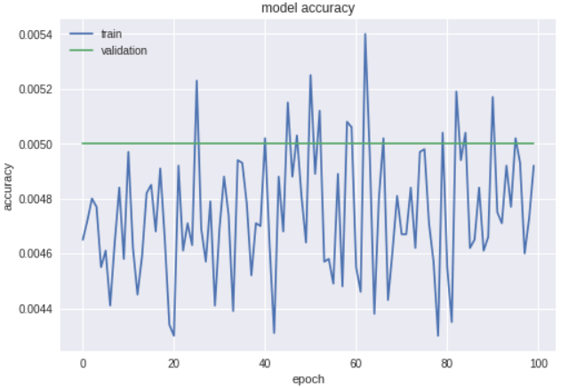

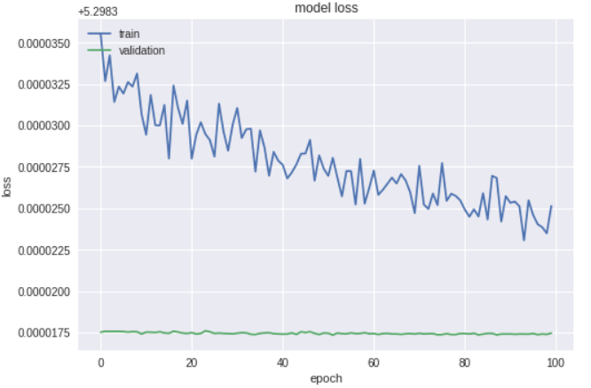

**Experiment 5:**

No of epochs: 50

Batch size: 95

Number of Conv layers: 3

Learning rate:0.0001

Optimizer: Adam

Activation functions: relu / elu

Dropout rates: 0.25

Optimizer: Adam

Train on 100000 samples, validate on 10000 samples

Epoch 1/50

100000/100000 [==============================] - 17s 166us/step - loss: 5.3029 - acc: 0.0047 - val_loss: 5.3011 - val_acc: 0.0050

Epoch 2/50

100000/100000 [==============================] - 15s 153us/step - loss: 5.3027 - acc: 0.0053 - val_loss: 5.3013 - val_acc: 0.0050

Epoch 3/50

100000/100000 [==============================] - 15s 153us/step - loss: 5.3026 - acc: 0.0050 - val_loss: 5.3001 - val_acc: 0.0050

Epoch 4/50

100000/100000 [==============================] - 15s 152us/step - loss: 5.3027 - acc: 0.0050 - val_loss: 5.3011 - val_acc: 0.0050

Epoch 5/50

100000/100000 [==============================] - 15s 153us/step - loss: 5.3026 - acc: 0.0053 - val_loss: 5.3004 - val_acc: 0.0050

Epoch 6/50

100000/100000 [==============================] - 15s 153us/step - loss: 5.3024 - acc: 0.0047 - val_loss: 5.3005 - val_acc: 0.0050

Epoch 7/50

100000/100000 [==============================] - 15s 153us/step - loss: 5.3026 - acc: 0.0047 - val_loss: 5.3019 - val_acc: 0.0050

Epoch 8/50

100000/100000 [==============================] - 15s 153us/step - loss: 5.3025 - acc: 0.0048 - val_loss: 5.3014 - val_acc: 0.0050

Epoch 9/50

100000/100000 [==============================] - 15s 153us/step - loss: 5.3023 - acc: 0.0047 - val_loss: 5.3003 - val_acc: 0.0050

Epoch 10/50

100000/100000 [==============================] - 15s 153us/step - loss: 5.3024 - acc: 0.0049 - val_loss: 5.3009 - val_acc: 0.0050

Epoch 11/50

100000/100000 [==============================] - 15s 152us/step - loss: 5.3023 - acc: 0.0048 - val_loss: 5.3018 - val_acc: 0.0050

Epoch 12/50

100000/100000 [==============================] - 15s 151us/step - loss: 5.3021 - acc: 0.0051 - val_loss: 5.3005 - val_acc: 0.0050

Epoch 13/50

100000/100000 [==============================] - 15s 152us/step - loss: 5.3020 - acc: 0.0047 - val_loss: 5.3012 - val_acc: 0.0050

Epoch 14/50

100000/100000 [==============================] - 15s 153us/step - loss: 5.3020 - acc: 0.0045 - val_loss: 5.3004 - val_acc: 0.0050

Epoch 15/50

100000/100000 [==============================] - 15s 153us/step - loss: 5.3019 - acc: 0.0051 - val_loss: 5.3007 - val_acc: 0.0050

Epoch 16/50

100000/100000 [==============================] - 15s 153us/step - loss: 5.3018 - acc: 0.0047 - val_loss: 5.3014 - val_acc: 0.0050

Epoch 17/50

100000/100000 [==============================] - 15s 152us/step - loss: 5.3018 - acc: 0.0048 - val_loss: 5.3006 - val_acc: 0.0050

Epoch 18/50

100000/100000 [==============================] - 15s 152us/step - loss: 5.3019 - acc: 0.0047 - val_loss: 5.3000 - val_acc: 0.0050

Epoch 19/50

100000/100000 [==============================] - 15s 153us/step - loss: 5.3016 - acc: 0.0048 - val_loss: 5.2996 - val_acc: 0.0050

Epoch 20/50

100000/100000 [==============================] - 15s 153us/step - loss: 5.3018 - acc: 0.0047 - val_loss: 5.2997 - val_acc: 0.0050

Epoch 21/50

100000/100000 [==============================] - 15s 153us/step - loss: 5.3017 - acc: 0.0050 - val_loss: 5.3002 - val_acc: 0.0050

Epoch 22/50

100000/100000 [==============================] - 15s 153us/step - loss: 5.3017 - acc: 0.0049 - val_loss: 5.2997 - val_acc: 0.0050

Epoch 23/50

100000/100000 [==============================] - 15s 153us/step - loss: 5.3013 - acc: 0.0050 - val_loss: 5.3000 - val_acc: 0.0050

Epoch 24/50

100000/100000 [==============================] - 15s 152us/step - loss: 5.3016 - acc: 0.0047 - val_loss: 5.2999 - val_acc: 0.0050

Epoch 25/50

100000/100000 [==============================] - 15s 152us/step - loss: 5.3014 - acc: 0.0049 - val_loss: 5.3013 - val_acc: 0.0050

Epoch 26/50

100000/100000 [==============================] - 15s 153us/step - loss: 5.3012 - acc: 0.0051 - val_loss: 5.3004 - val_acc: 0.0050

Epoch 27/50

100000/100000 [==============================] - 15s 153us/step - loss: 5.3012 - acc: 0.0052 - val_loss: 5.3002 - val_acc: 0.0050

Epoch 28/50

100000/100000 [==============================] - 15s 153us/step - loss: 5.3014 - acc: 0.0044 - val_loss: 5.3002 - val_acc: 0.0050

Epoch 29/50

100000/100000 [==============================] - 15s 153us/step - loss: 5.3013 - acc: 0.0048 - val_loss: 5.2997 - val_acc: 0.0050

Epoch 30/50

100000/100000 [==============================] - 15s 153us/step - loss: 5.3013 - acc: 0.0046 - val_loss: 5.3003 - val_acc: 0.0050

Epoch 31/50

100000/100000 [==============================] - 15s 153us/step - loss: 5.3012 - acc: 0.0045 - val_loss: 5.2997 - val_acc: 0.0050

Epoch 32/50

100000/100000 [==============================] - 15s 152us/step - loss: 5.3010 - acc: 0.0049 - val_loss: 5.2998 - val_acc: 0.0050

Epoch 33/50

100000/100000 [==============================] - 15s 152us/step - loss: 5.3009 - acc: 0.0049 - val_loss: 5.2997 - val_acc: 0.0050

Epoch 34/50

100000/100000 [==============================] - 15s 153us/step - loss: 5.3010 - acc: 0.0047 - val_loss: 5.2998 - val_acc: 0.0050

Epoch 35/50

100000/100000 [==============================] - 15s 153us/step - loss: 5.3009 - acc: 0.0046 - val_loss: 5.3000 - val_acc: 0.0050

Epoch 36/50

100000/100000 [==============================] - 15s 153us/step - loss: 5.3010 - acc: 0.0046 - val_loss: 5.2999 - val_acc: 0.0050

Epoch 37/50

100000/100000 [==============================] - 15s 153us/step - loss: 5.3011 - acc: 0.0047 - val_loss: 5.3001 - val_acc: 0.0050

Epoch 38/50

100000/100000 [==============================] - 15s 153us/step - loss: 5.3009 - acc: 0.0048 - val_loss: 5.2998 - val_acc: 0.0050

Epoch 39/50

100000/100000 [==============================] - 15s 153us/step - loss: 5.3007 - acc: 0.0050 - val_loss: 5.3003 - val_acc: 0.0050

Epoch 40/50

100000/100000 [==============================] - 15s 153us/step - loss: 5.3010 - acc: 0.0047 - val_loss: 5.2995 - val_acc: 0.0050

Epoch 41/50

100000/100000 [==============================] - 15s 153us/step - loss: 5.3007 - acc: 0.0046 - val_loss: 5.3006 - val_acc: 0.0050

Epoch 42/50

100000/100000 [==============================] - 15s 153us/step - loss: 5.3008 - acc: 0.0048 - val_loss: 5.3001 - val_acc: 0.0050

Epoch 43/50

100000/100000 [==============================] - 15s 153us/step - loss: 5.3006 - acc: 0.0047 - val_loss: 5.3003 - val_acc: 0.0050

Epoch 44/50

100000/100000 [==============================] - 15s 152us/step - loss: 5.3008 - acc: 0.0049 - val_loss: 5.3004 - val_acc: 0.0050

Epoch 45/50

100000/100000 [==============================] - 15s 153us/step - loss: 5.3006 - acc: 0.0047 - val_loss: 5.2991 - val_acc: 0.0050

Epoch 46/50

100000/100000 [==============================] - 15s 152us/step - loss: 5.3004 - acc: 0.0050 - val_loss: 5.3003 - val_acc: 0.0050

Epoch 47/50

100000/100000 [==============================] - 15s 152us/step - loss: 5.3006 - acc: 0.0047 - val_loss: 5.2996 - val_acc: 0.0050

Epoch 48/50

100000/100000 [==============================] - 15s 153us/step - loss: 5.3005 - acc: 0.0047 - val_loss: 5.2996 - val_acc: 0.0050

Epoch 49/50

100000/100000 [==============================] - 15s 152us/step - loss: 5.3005 - acc: 0.0050 - val_loss: 5.2996 - val_acc: 0.0050

Epoch 50/50

100000/100000 [==============================] - 15s 152us/step - loss: 5.3005 - acc: 0.0046 - val_loss: 5.3005 - val_acc: 0.0050

10000/10000 [==============================] - 1s 122us/step

Test loss: 5.300455449676513

Test accuracy: 0.005

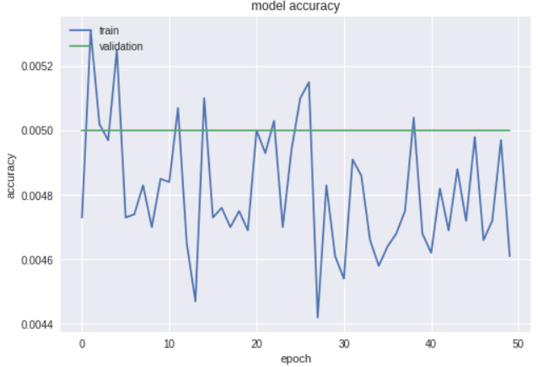

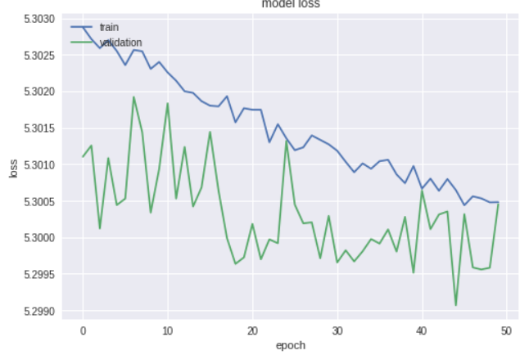

**Experiment 6:**

No of epochs: 15

Batch size: 128

Number of Conv layers: 6

Learning rate:0.001

Optimizer: SGD

Activation functions: relu

Dropout rates: 0.25

Train on 100000 samples, validate on 10000 samples

Epoch 1/15

100000/100000 [==============================] - 192s 2ms/step - loss: 5.2988 - acc: 0.0047 - val_loss: 5.2983 - val_acc: 0.0050

Epoch 2/15

100000/100000 [==============================] - 192s 2ms/step - loss: 5.2987 - acc: 0.0049 - val_loss: 5.2982 - val_acc: 0.0050

Epoch 3/15

100000/100000 [==============================] - 192s 2ms/step - loss: 5.2978 - acc: 0.0052 - val_loss: 5.2925 - val_acc: 0.0078

Epoch 4/15

100000/100000 [==============================] - 188s 2ms/step - loss: 5.1993 - acc: 0.0114 - val_loss: 5.0854 - val_acc: 0.0143

Epoch 5/15

100000/100000 [==============================] - 189s 2ms/step - loss: 5.0470 - acc: 0.0202 - val_loss: 4.9548 - val_acc: 0.0264

Epoch 6/15

100000/100000 [==============================] - 2402s 24ms/step - loss: 4.9103 - acc: 0.0340 - val_loss: 4.8130 - val_acc: 0.0421

Epoch 7/15

100000/100000 [==============================] - 188s 2ms/step - loss: 4.7792 - acc: 0.0480 - val_loss: 4.6793 - val_acc: 0.0600

Epoch 8/15

100000/100000 [==============================] - 188s 2ms/step - loss: 4.6763 - acc: 0.0580 - val_loss: 4.6578 - val_acc: 0.0606

Epoch 9/15

100000/100000 [==============================] - 189s 2ms/step - loss: 4.5846 - acc: 0.0688 - val_loss: 4.5591 - val_acc: 0.0709

Epoch 10/15

100000/100000 [==============================] - 187s 2ms/step - loss: 4.4951 - acc: 0.0789 - val_loss: 4.3849 - val_acc: 0.0900

Epoch 11/15

100000/100000 [==============================] - 1136s 11ms/step - loss: 4.4167 - acc: 0.0899 - val_loss: 4.3029 - val_acc: 0.1042

Epoch 12/15

100000/100000 [==============================] - 189s 2ms/step - loss: 4.3496 - acc: 0.0981 - val_loss: 4.2775 - val_acc: 0.1097

Epoch 13/15

100000/100000 [==============================] - 189s 2ms/step - loss: 4.2872 - acc: 0.1071 - val_loss: 4.2635 - val_acc: 0.1084

Epoch 14/15

100000/100000 [==============================] - 189s 2ms/step - loss: 4.2391 - acc: 0.1125 - val_loss: 4.1567 - val_acc: 0.1215

Epoch 15/15

100000/100000 [==============================] - 187s 2ms/step - loss: 4.1893 - acc: 0.1181 - val_loss: 4.1502 - val_acc: 0

10000/10000 [==============================] - 7s 738us/step

Test loss: 4.150217217254639

Test accuracy: 0.1245

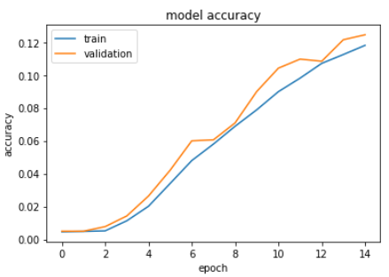

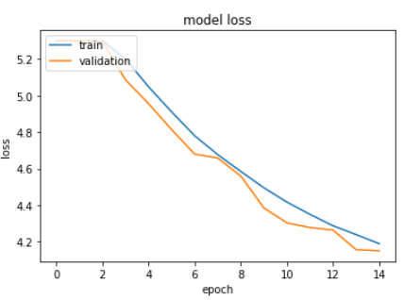

**Experiment 7:**

No of epochs: 20

Batch size: 150

Number of Conv layers: 6

Learning rate:0.01

Optimizer: Adam

Activation functions: relu

Dropout rates: 0.25

Train on 100000 samples, validate on 10000 samples

Epoch 1/20

100000/100000 [==============================] - 188s 2ms/step - loss: 5.3120 - acc: 0.0047 - val_loss: 5.3000 - val_acc: 0.0050

Epoch 2/20

100000/100000 [==============================] - 186s 2ms/step - loss: 5.3020 - acc: 0.0047 - val_loss: 5.3003 - val_acc: 0.0050

Epoch 3/20

100000/100000 [==============================] - 186s 2ms/step - loss: 5.3019 - acc: 0.0048 - val_loss: 5.3002 - val_acc: 0.0050

Epoch 4/20

100000/100000 [==============================] - 186s 2ms/step - loss: 5.3019 - acc: 0.0044 - val_loss: 5.3003 - val_acc: 0.0050

Epoch 5/20

100000/100000 [==============================] - 186s 2ms/step - loss: 5.3019 - acc: 0.0048 - val_loss: 5.3003 - val_acc: 0.0050

Epoch 6/20

100000/100000 [==============================] - 186s 2ms/step - loss: 5.3020 - acc: 0.0044 - val_loss: 5.3004 - val_acc: 0.0050

Epoch 7/20

100000/100000 [==============================] - 185s 2ms/step - loss: 5.3019 - acc: 0.0047 - val_loss: 5.3003 - val_acc: 0.0050

Epoch 8/20

100000/100000 [==============================] - 186s 2ms/step - loss: 5.3019 - acc: 0.0043 - val_loss: 5.3006 - val_acc: 0.0050

Epoch 9/20

100000/100000 [==============================] - 186s 2ms/step - loss: 5.3020 - acc: 0.0045 - val_loss: 5.3004 - val_acc: 0.0050

Epoch 10/20

100000/100000 [==============================] - 185s 2ms/step - loss: 5.3020 - acc: 0.0045 - val_loss: 5.3005 - val_acc: 0.0050

Epoch 11/20

100000/100000 [==============================] - 413s 4ms/step - loss: 5.3021 - acc: 0.0046 - val_loss: 5.3000 - val_acc: 0.0050

Epoch 12/20

100000/100000 [==============================] - 188s 2ms/step - loss: 5.3020 - acc: 0.0048 - val_loss: 5.3003 - val_acc: 0.0050

Epoch 13/20

100000/100000 [==============================] - 186s 2ms/step - loss: 5.3020 - acc: 0.0047 - val_loss: 5.3003 - val_acc: 0.0050

Epoch 14/20

100000/100000 [==============================] - 186s 2ms/step - loss: 5.3020 - acc: 0.0045 - val_loss: 5.3001 - val_acc: 0.0050

Epoch 15/20

100000/100000 [==============================] - 186s 2ms/step - loss: 5.3018 - acc: 0.0050 - val_loss: 5.3005 - val_acc: 0.0050

Epoch 16/20

100000/100000 [==============================] - 186s 2ms/step - loss: 5.3020 - acc: 0.0049 - val_loss: 5.3002 - val_acc: 0.0050

Epoch 17/20

100000/100000 [==============================] - 187s 2ms/step - loss: 5.3018 - acc: 0.0044 - val_loss: 5.3007 - val_acc: 0.0050

Epoch 18/20

100000/100000 [==============================] - 131s 1ms/step - loss: 5.3019 - acc: 0.0047 - val_loss: 5.3002 - val_acc: 0.0050

Epoch 19/20

100000/100000 [==============================] - 124s 1ms/step - loss: 5.3018 - acc: 0.0047 - val_loss: 5.3007 - val_acc: 0.0050

Epoch 20/20

100000/100000 [==============================] - 124s 1ms/step - loss: 5.3021 - acc: 0.0047 - val_loss: 5.3002 - val_acc: 0.0050

10000/10000 [==============================] - 4s 394us/step

Test loss: 5.300190341186523

Test accuracy: 0.005

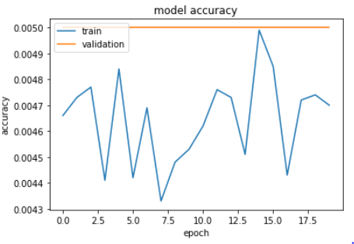

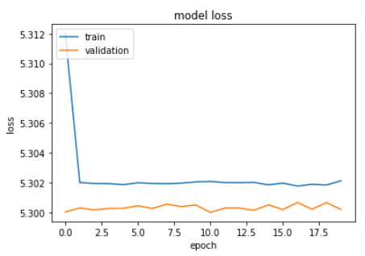

**Autokeras to tune hyperparameters**

Autokeras is an open source python package written in the very easy to use deep learning library keras. We are using this autokeras package to tune the hyperparameters. We executed the tiny imageNet data set using autokeras and got below results:

Initializing search.

Initialization finished.

+----------------------------------------------+

| Training model 0 |

+----------------------------------------------+

No loss decrease after 5 epochs.

Saving model.

+--------------------------------------------------------------------------+

| Model ID | Loss | Metric Value |

+--------------------------------------------------------------------------+

| 0 | 15.962398386001587 | 0.14440000000000003 |

+--------------------------------------------------------------------------+

+----------------------------------------------+

| Training model 1 |

+----------------------------------------------+

No loss decrease after 5 epochs.

Saving model.

+--------------------------------------------------------------------------+

| Model ID | Loss | Metric Value |

+--------------------------------------------------------------------------+

| 1 | 14.571921348571777 | 0.22359999999999997 |

+--------------------------------------------------------------------------+

+----------------------------------------------+

| Training model 2 |

+----------------------------------------------+

Epoch-20, Current Metric - 0.212: 33%|███████▋ | 260/778 [02:20<04:50, 1.78 batch/s]Time is out.

No loss decrease after 30 epochs.

**Comments**: When we ran tiny image-net dataset using auto keras, it ran for nearly 6 hours. For Model 1 we got nearly 14% accuracy for 5 epochs. After that model ran for several more hours and we got accuracy nearly 22% for 20 epochs

**Implement the Alexnet models in Keras**

AlexNet is the name of convolution neural Network. Alexnet consists of total 8 layers out of which first five layers are convolution layers followed by some maxpooling and remaining three layers are fully connected layers. We have created Alexnet and ran imagenet dataset. Results we got for that are as below:

**Experiment 1:**

Batch size=128

epochs=10

learning rate= 0.01

optimizer= SGD

Train on 100000 samples, validate on 10000 samples

Epoch 1/10

100000/100000 [==============================] - 454s 5ms/step - loss: 5.2988 - acc: 0.0043 - val_loss: 5.2983 - val_acc: 0.0051

Epoch 2/10

100000/100000 [==============================] - 442s 4ms/step - loss: 5.2987 - acc: 0.0045 - val_loss: 5.2981 - val_acc: 0.0053

Epoch 3/10

100000/100000 [==============================] - 442s 4ms/step - loss: 5.2985 - acc: 0.0048 - val_loss: 5.2973 - val_acc: 0.0051

Epoch 4/10

100000/100000 [==============================] - 442s 4ms/step - loss: 5.2968 - acc: 0.0057 - val_loss: 5.2926 - val_acc: 0.0091

Epoch 5/10

100000/100000 [==============================] - 442s 4ms/step - loss: 5.2851 - acc: 0.0074 - val_loss: 5.2719 - val_acc: 0.0089

Epoch 6/10

100000/100000 [==============================] - 443s 4ms/step - loss: 5.2310 - acc: 0.0090 - val_loss: 5.1577 - val_acc: 0.0099

Epoch 7/10

100000/100000 [==============================] - 442s 4ms/step - loss: 5.1320 - acc: 0.0121 - val_loss: 5.0617 - val_acc: 0.0171

Epoch 8/10

100000/100000 [==============================] - 442s 4ms/step - loss: 5.0641 - acc: 0.0161 - val_loss: 5.0017 - val_acc: 0.0230

Epoch 9/10

100000/100000 [==============================] - 442s 4ms/step - loss: 5.0000 - acc: 0.0222 - val_loss: 4.9409 - val_acc: 0.0287

Epoch 10/10

100000/100000 [==============================] - 442s 4ms/step - loss: 4.9339 - acc: 0.0274 - val_loss: 5.0604 - val_acc: 0.0240

10000/10000 [==============================] - 20s 2ms/step

Test loss: 5.060372068786621

Test accuracy: 0.024

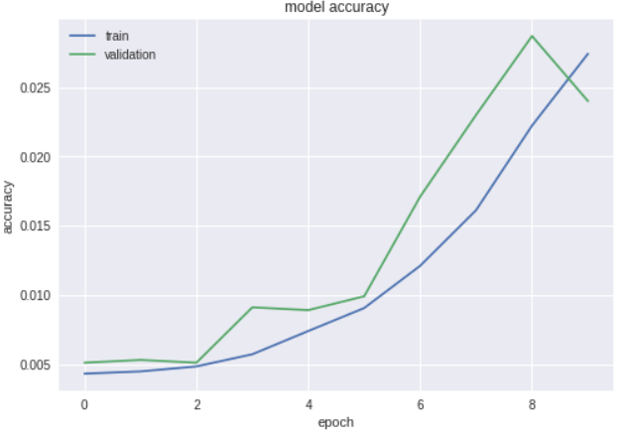

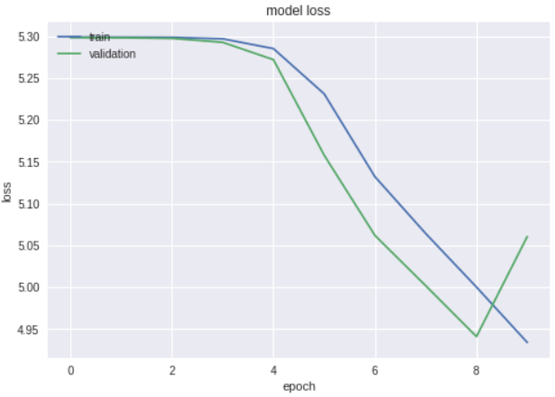

**Comments**: We can see that the accuracy for training and testing data is nearly 2.5%. We will change model parameters like number of neurons, optimizer etc. and see the results.

**Experiment 2:**

Batch size=128

epochs=10

learning rate= 0.01

optimizer= SGD

Layer (type) Output Shape Param #

=================================================================

zero_padding2d_1 (ZeroPaddin (None, 7, 36, 32) 0

_________________________________________________________________

conv2d_1 (Conv2D) (None, 2, 16, 32) 25632

_________________________________________________________________

activation_1 (Activation) (None, 2, 16, 32) 0

_________________________________________________________________

zero_padding2d_2 (ZeroPaddin (None, 4, 18, 32) 0

_________________________________________________________________

conv2d_2 (Conv2D) (None, 2, 16, 32) 9248

_________________________________________________________________

activation_2 (Activation) (None, 2, 16, 32) 0

_________________________________________________________________

zero_padding2d_3 (ZeroPaddin (None, 4, 18, 32) 0

_________________________________________________________________

conv2d_3 (Conv2D) (None, 1, 8, 128) 36992

_________________________________________________________________

activation_3 (Activation) (None, 1, 8, 128) 0

_________________________________________________________________

dropout_1 (Dropout) (None, 1, 8, 128) 0

_________________________________________________________________

zero_padding2d_4 (ZeroPaddin (None, 3, 10, 128) 0

_________________________________________________________________

conv2d_4 (Conv2D) (None, 1, 8, 128) 147584

_________________________________________________________________

activation_4 (Activation) (None, 1, 8, 128) 0

_________________________________________________________________

zero_padding2d_5 (ZeroPaddin (None, 3, 10, 128) 0

_________________________________________________________________

conv2d_5 (Conv2D) (None, 1, 4, 256) 295168

_________________________________________________________________

activation_5 (Activation) (None, 1, 4, 256) 0

_________________________________________________________________

zero_padding2d_6 (ZeroPaddin (None, 3, 6, 256) 0

_________________________________________________________________

conv2d_6 (Conv2D) (None, 1, 4, 256) 590080

_________________________________________________________________

activation_6 (Activation) (None, 1, 4, 256) 0

_________________________________________________________________

dropout_2 (Dropout) (None, 1, 4, 256) 0

_________________________________________________________________

zero_padding2d_7 (ZeroPaddin (None, 3, 6, 256) 0

_________________________________________________________________

conv2d_7 (Conv2D) (None, 1, 2, 512) 1180160

_________________________________________________________________

activation_7 (Activation) (None, 1, 2, 512) 0

_________________________________________________________________

zero_padding2d_8 (ZeroPaddin (None, 3, 4, 512) 0

_________________________________________________________________

conv2d_8 (Conv2D) (None, 1, 2, 512) 2359808

_________________________________________________________________

activation_8 (Activation) (None, 1, 2, 512) 0

_________________________________________________________________

zero_padding2d_9 (ZeroPaddin (None, 3, 4, 512) 0

_________________________________________________________________

conv2d_9 (Conv2D) (None, 1, 1, 1024) 4719616

_________________________________________________________________

activation_9 (Activation) (None, 1, 1, 1024) 0

_________________________________________________________________

dropout_3 (Dropout) (None, 1, 1, 1024) 0

_________________________________________________________________

flatten_1 (Flatten) (None, 1024) 0

_________________________________________________________________

dense_1 (Dense) (None, 200) 205000

_________________________________________________________________

activation_10 (Activation) (None, 200) 0

_________________________________________________________________

dropout_4 (Dropout) (None, 200) 0

=================================================================

Total params: 9,569,288

Trainable params: 9,569,288

Non-trainable params: 0

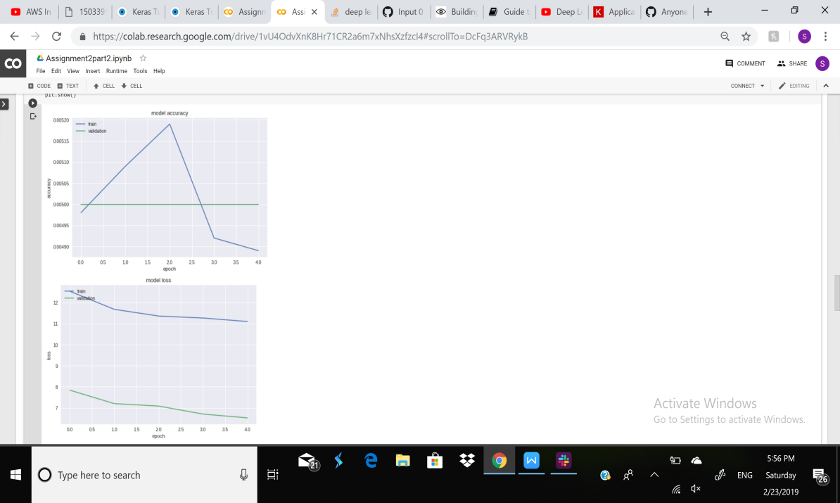

**Experiment 3:**

Batch size=300

epochs=20

learning rate= 0.001

optimizer= Adam

Train on 100000 samples, validate on 10000 samples

Epoch 1/20

100000/100000 [==============================] - 1004s 10ms/step - loss: 5.2999 - acc: 0.0049 - val_loss: 5.2981 - val_acc: 0.0052

Epoch 2/20

100000/100000 [==============================] - 1027s 10ms/step - loss: 5.2995 - acc: 0.0053 - val_loss: 5.2984 - val_acc: 0.0050

Epoch 3/20

100000/100000 [==============================] - 1048s 10ms/step - loss: 5.2916 - acc: 0.0059 - val_loss: 5.2461 - val_acc: 0.0104

Epoch 4/20

100000/100000 [==============================] - 679s 7ms/step - loss: 5.1433 - acc: 0.0121 - val_loss: 5.0491 - val_acc: 0.0196

Epoch 5/20

100000/100000 [==============================] - 680s 7ms/step - loss: 5.0199 - acc: 0.0205 - val_loss: 4.9425 - val_acc: 0.0259

Epoch 6/20

100000/100000 [==============================] - 859s 9ms/step - loss: 4.9504 - acc: 0.0259 - val_loss: 4.9196 - val_acc: 0.0302

Epoch 7/20

100000/100000 [==============================] - 673s 7ms/step - loss: 4.8929 - acc: 0.0321 - val_loss: 4.8148 - val_acc: 0.0386

Epoch 8/20

100000/100000 [==============================] - 672s 7ms/step - loss: 4.8246 - acc: 0.0388 - val_loss: 4.7352 - val_acc: 0.0473

Epoch 9/20

100000/100000 [==============================] - 657s 7ms/step - loss: 4.7503 - acc: 0.0451 - val_loss: 4.6540 - val_acc: 0.0561

Epoch 10/20

100000/100000 [==============================] - 642s 6ms/step - loss: 4.6901 - acc: 0.0524 - val_loss: 4.6358 - val_acc: 0.0549

Epoch 11/20

100000/100000 [==============================] - 637s 6ms/step - loss: 4.6471 - acc: 0.0570 - val_loss: 4.5757 - val_acc: 0.0681

Epoch 12/20

100000/100000 [==============================] - 635s 6ms/step - loss: 4.6066 - acc: 0.0628 - val_loss: 4.5396 - val_acc: 0.0706

Epoch 13/20

100000/100000 [==============================] - 1290s 13ms/step - loss: 4.5776 - acc: 0.0667 - val_loss: 4.5132 - val_acc: 0.0770

Epoch 14/20

100000/100000 [==============================] - 896s 9ms/step - loss: 4.5442 - acc: 0.0693 - val_loss: 4.5193 - val_acc: 0.0765

Epoch 15/20

100000/100000 [==============================] - 1024s 10ms/step - loss: 4.5141 - acc: 0.0726 - val_loss: 4.4639 - val_acc: 0.0829

Epoch 16/20

100000/100000 [==============================] - 1023s 10ms/step - loss: 4.4881 - acc: 0.0765 - val_loss: 4.4378 - val_acc: 0.0891

Epoch 17/20

100000/100000 [==============================] - 899s 9ms/step - loss: 4.4612 - acc: 0.0804 - val_loss: 4.4167 - val_acc: 0.0905

Epoch 18/20

100000/100000 [==============================] - 671s 7ms/step - loss: 4.4376 - acc: 0.0834 - val_loss: 4.3956 - val_acc: 0.0913

Epoch 19/20

100000/100000 [==============================] - 666s 7ms/step - loss: 4.4130 - acc: 0.0861 - val_loss: 4.3980 - val_acc: 0.0891

Epoch 20/20

100000/100000 [==============================] - 1147s 11ms/step - loss: 4.3928 - acc: 0.0894 - val_loss: 4.3941 - val_acc: 0.0921

10000/10000 [==============================] - 15s 2ms/step

Test loss: 4.3940801948547366

Test accuracy: 0.0921

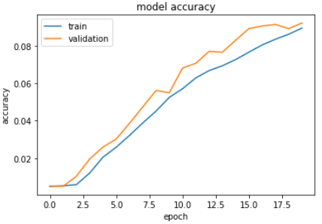

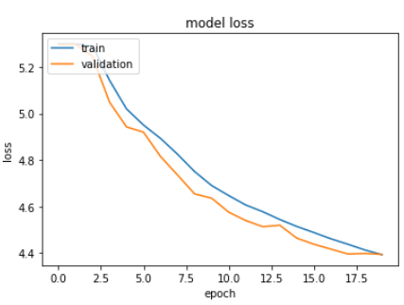

**Pretrained model NASNetMobile**

**Experiment 1:**

**NASNET IMAGENET BATCH SIZE= 500, EPOCH =2 OPTIMIZER=SGD**

_________________________________________________________________

Layer (type) Output Shape Param #

=================================================================

NASNet (Model) (None, 1056) 4269716

_________________________________________________________________

dense_2 (Dense) (None, 200) 211400

=================================================================

Total params: 4,481,116

Trainable params: 4,444,378

Non-trainable params: 36,738

Train on 100000 samples, validate on 10000 samples

Epoch 1/2

100000/100000 [==============================] - 188s 2ms/step - loss: 5.5560 - acc: 0.0000e+00 - val_loss: 16.0257 - val_acc: 0.0051

Epoch 2/2

100000/100000 [==============================] - 105s 1ms/step - loss: 5.3084 - acc: 0.0020 - val_loss: 15.0459 - val_acc: 0.0047

**Experment 2:**

NASNET

history=model.fit(X_train, y_train,

batch_size=128,

epochs=10,

validation_data=(X_test, y_test),

shuffle=False)

EPOCH= 10, BATCH SIZE =128, OPTIMIZER = SGD

Train on 100000 samples, validate on 10000 samples

Epoch 1/10

100000/100000 [==============================] - 272s 3ms/step - loss: 5.2305 - acc: 0.0054 - val_loss: 13.1441 - val_acc: 0.0037

Epoch 2/10

100000/100000 [==============================] - 219s 2ms/step - loss: 5.0822 - acc: 0.0110 - val_loss: 14.4295 - val_acc: 0.0052

Epoch 3/10

100000/100000 [==============================] - 221s 2ms/step - loss: 5.0263 - acc: 0.0100 - val_loss: 7.4336 - val_acc: 0.0045

Epoch 4/10

100000/100000 [==============================] - 221s 2ms/step - loss: 5.0260 - acc: 0.0117 - val_loss: 5.5344 - val_acc: 0.0044

Epoch 5/10

100000/100000 [==============================] - 219s 2ms/step - loss: 5.2530 - acc: 0.0064 - val_loss: 5.3350 - val_acc: 0.0046

Epoch 6/10

100000/100000 [==============================] - 221s 2ms/step - loss: 5.3495 - acc: 0.0057 - val_loss: 7.9907 - val_acc: 0.0045

Epoch 7/10

100000/100000 [==============================] - 222s 2ms/step - loss: 5.0753 - acc: 0.0085 - val_loss: 7.1957 - val_acc: 0.0044

Epoch 8/10

100000/100000 [==============================] - 222s 2ms/step - loss: 5.2464 - acc: 0.0038 - val_loss: 5.9065 - val_acc: 0.0050

Epoch 9/10

100000/100000 [==============================] - 222s 2ms/step - loss: 5.2512 - acc: 0.0038 - val_loss: 5.6915 - val_acc: 0.0053

Epoch 10/10

100000/100000 [==============================] - 222s 2ms/step - loss: 5.2364 - acc: 0.0062 - val_loss: 5.5307 - val_acc: 0.0048

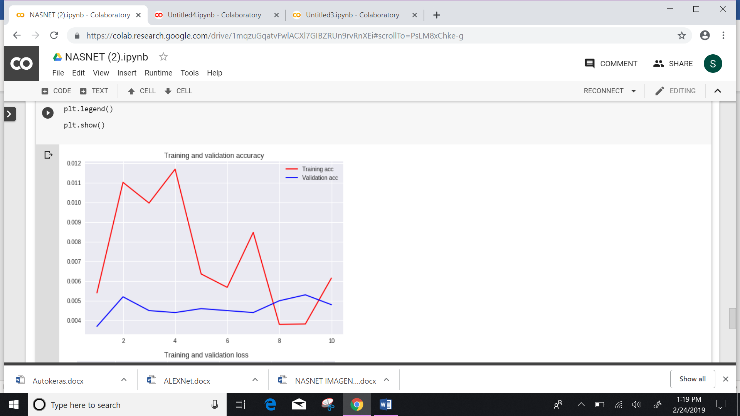



**Experiment 3:**

Optimizer : rmsprop

Epochs: 7

Batch Size: 256

optimizer='rmsprop',

batch_size=256,

Train on 100000 samples, validate on 10000 samples

Epoch 1/7

100000/100000 [==============================] - 200s 2ms/step - loss: 5.5398 - acc: 0.0085 - val_loss: 6.6268 - val_acc: 0.0079

Epoch 2/7

100000/100000 [==============================] - 146s 1ms/step - loss: 4.9637 - acc: 0.0066 - val_loss: 16.0364 - val_acc: 0.0050

Epoch 3/7

100000/100000 [==============================] - 145s 1ms/step - loss: 4.3548 - acc: 0.0142 - val_loss: 15.9546 - val_acc: 0.0050

Epoch 4/7

100000/100000 [==============================] - 145s 1ms/step - loss: 3.7449 - acc: 0.0229 - val_loss: 16.0224 - val_acc: 0.0050

Epoch 5/7

100000/100000 [==============================] - 145s 1ms/step - loss: 3.2066 - acc: 0.0503 - val_loss: 16.0375 - val_acc: 0.0050

Epoch 6/7

100000/100000 [==============================] - 146s 1ms/step - loss: 3.0518 - acc: 0.0698 - val_loss: 16.0375 - val_acc: 0.0050

Epoch 7/7

100000/100000 [==============================] - 145s 1ms/step - loss: 2.6698 - acc: 0.0950 - val_loss: 16.0375 - val_acc: 0.0050

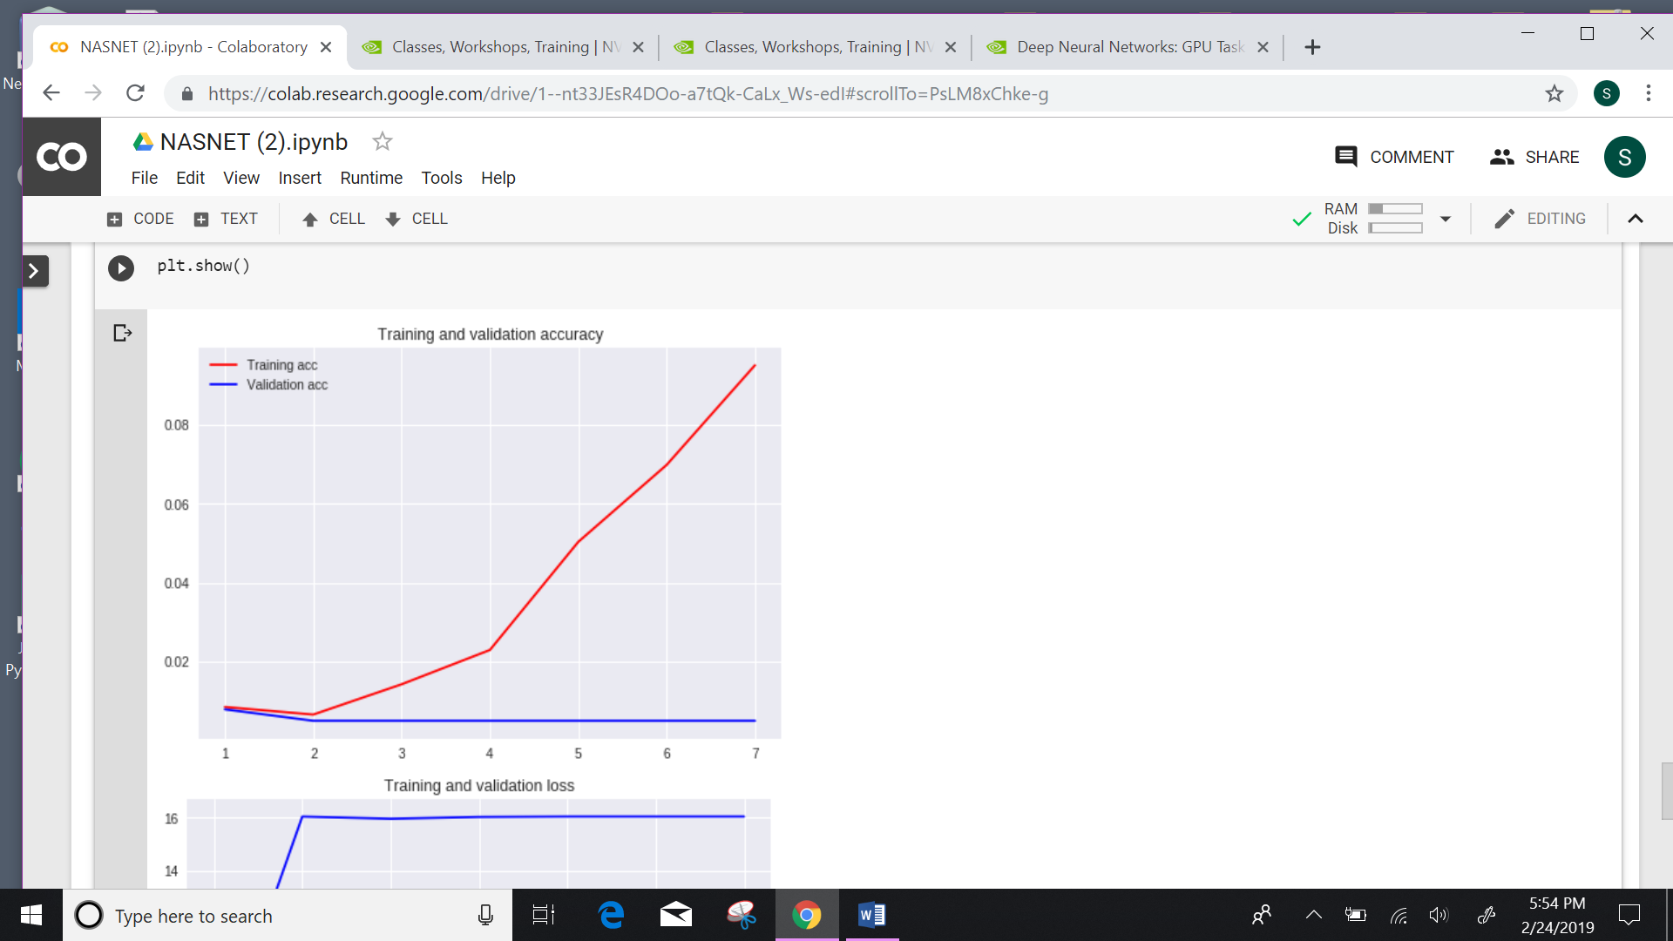

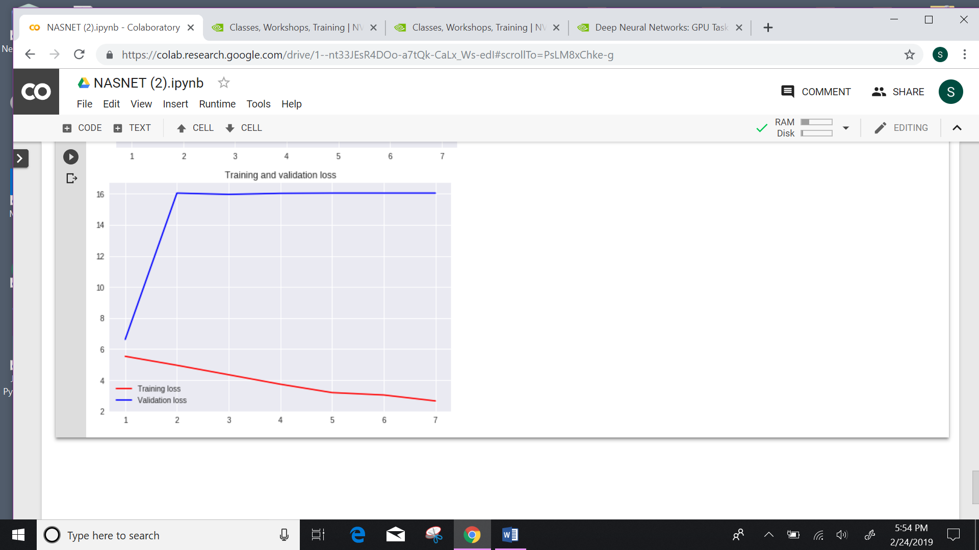

**Transfer Learning**

In this section, we will use the pretrained model of NASNet Mobile in order to train the cifar 10 dataset. Below are the results which we received after using same model of NASNet Mobile trained with imageNet dataset for cifar 10 dataset:

**Experiment 1:**

**NASNET CIFAR 10 BATCH SIZE= 500, EPOCH =2 OPTIMIZER=SGD**

Epoch 1/2

50000/50000 [==============================] - 146s 3ms/step - loss: 1.8292 - acc: 0.3260 - val_loss: 1.9397 - val_acc: 0.3825

Epoch 2/2

50000/50000 [==============================] - 54s 1ms/step - loss: 1.4653 - acc: 0.4685 - val_loss: 2.7912 - val_acc: 0.3271

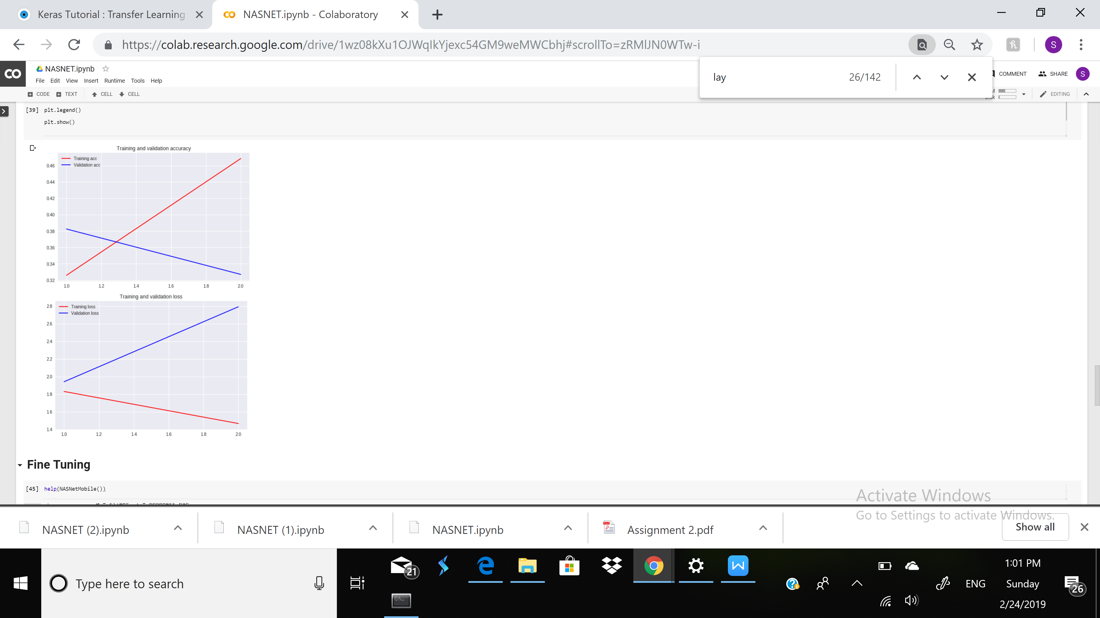

**Experiment 2:**

EPOCH =10, BATCH SIZE=256 , OPTIMIZER = SGD

Train on 50000 samples, validate on 10000 samples

Epoch 1/10

50000/50000 [==============================] - 168s 3ms/step - loss: 1.9084 - acc: 0.3020 - val_loss: 2.3374 - val_acc: 0.2616

Epoch 2/10

50000/50000 [==============================] - 113s 2ms/step - loss: 1.6049 - acc: 0.4088 - val_loss: 1.9181 - val_acc: 0.3339

Epoch 3/10

50000/50000 [==============================] - 113s 2ms/step - loss: 1.4745 - acc: 0.4580 - val_loss: 1.7449 - val_acc: 0.3990

Epoch 4/10

50000/50000 [==============================] - 113s 2ms/step - loss: 1.3843 - acc: 0.4979 - val_loss: 1.6458 - val_acc: 0.4303

Epoch 5/10

50000/50000 [==============================] - 113s 2ms/step - loss: 1.3100 - acc: 0.5244 - val_loss: 1.8245 - val_acc: 0.3946

Epoch 6/10

50000/50000 [==============================] - 113s 2ms/step - loss: 1.2459 - acc: 0.5517 - val_loss: 1.5969 - val_acc: 0.4526

Epoch 7/10

50000/50000 [==============================] - 113s 2ms/step - loss: 1.1918 - acc: 0.5692 - val_loss: 1.5351 - val_acc: 0.4625

Epoch 8/10

50000/50000 [==============================] - 113s 2ms/step - loss: 1.1340 - acc: 0.5953 - val_loss: 1.6486 - val_acc: 0.4410

Epoch 9/10

50000/50000 [==============================] - 113s 2ms/step - loss: 1.0926 - acc: 0.6080 - val_loss: 1.5398 - val_acc: 0.4792

Epoch 10/10

50000/50000 [==============================] - 113s 2ms/step - loss: 1.0444 - acc: 0.6260 - val_loss: 1.6802 - val_acc: 0.4638

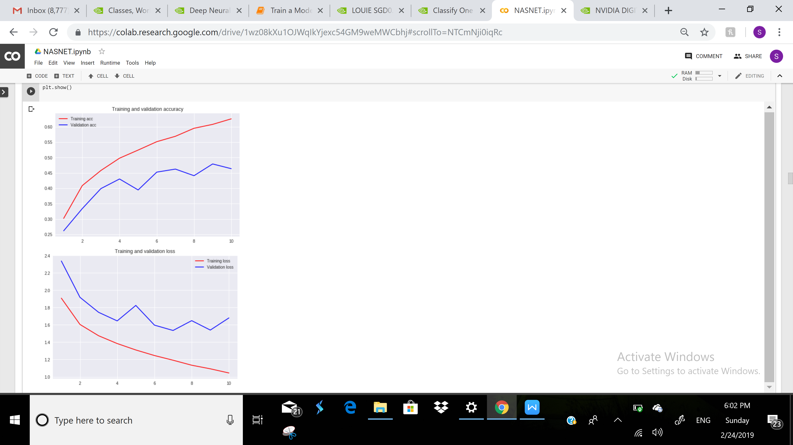

**Fine Tuning for CIFAR 10 Dataset**

In this section we are fine tuning out model by changing hyperparameters of the model. Below are the results:

**Experiment 1:**

EPOCH =10, SGD Optimizer, BATCH SIZE =256 with 4 DENSE LAYERS FROZEN

Epoch 1/10

50000/50000 [==============================] - 144s 3ms/step - loss: 0.6918 - acc: 0.7581 - val_loss: 1.6113 - val_acc: 0.4933

Epoch 2/10

50000/50000 [==============================] - 78s 2ms/step - loss: 0.5790 - acc: 0.8006 - val_loss: 1.6759 - val_acc: 0.4885

Epoch 3/10

50000/50000 [==============================] - 78s 2ms/step - loss: 0.4820 - acc: 0.8360 - val_loss: 1.7600 - val_acc: 0.4874

Epoch 4/10

50000/50000 [==============================] - 78s 2ms/step - loss: 0.4068 - acc: 0.8605 - val_loss: 1.7969 - val_acc: 0.5010

Epoch 5/10

50000/50000 [==============================] - 78s 2ms/step - loss: 0.3450 - acc: 0.8827 - val_loss: 1.8573 - val_acc: 0.4966

Epoch 6/10

50000/50000 [==============================] - 78s 2ms/step - loss: 0.2889 - acc: 0.9009 - val_loss: 1.9683 - val_acc: 0.4920

Epoch 7/10

50000/50000 [==============================] - 78s 2ms/step - loss: 0.2529 - acc: 0.9139 - val_loss: 2.1725 - val_acc: 0.4882

Epoch 8/10

50000/50000 [==============================] - 78s 2ms/step - loss: 0.2167 - acc: 0.9266 - val_loss: 2.4802 - val_acc: 0.4766

Epoch 9/10

50000/50000 [==============================] - 78s 2ms/step - loss: 0.1961 - acc: 0.9317 - val_loss: 2.4677 - val_acc: 0.4841

Epoch 10/10

50000/50000 [==============================] - 78s 2ms/step - loss: 0.1751 - acc: 0.9398 - val_loss: 2.5000 - val_acc: 0.4984

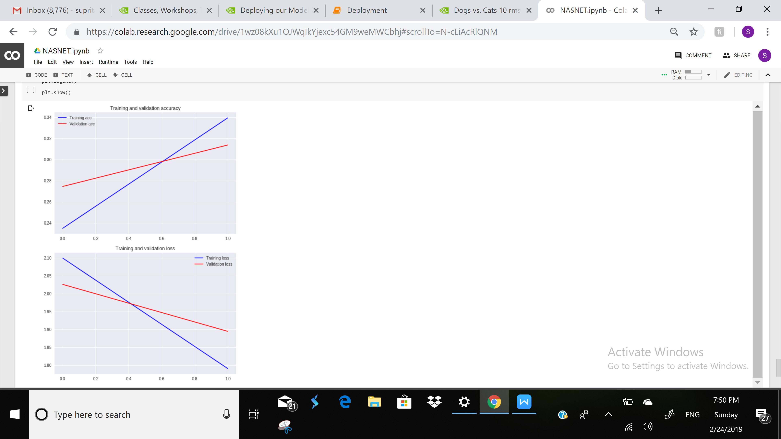

**Experiment 2:**

LAST 4 LAYERS FROZEN, BATCH SIZE =32, EPOCH=10, SGD Optimizer

Epoch 1/10

50000/50000 [==============================] - 476s 10ms/step - loss: 1.6126 - acc: 0.4353 - val_loss: 3.8205 - val_acc: 0.2702

Epoch 2/10

50000/50000 [==============================] - 411s 8ms/step - loss: 1.3375 - acc: 0.5241 - val_loss: 2.8531 - val_acc: 0.3196

Epoch 3/10

50000/50000 [==============================] - 411s 8ms/step - loss: 1.2253 - acc: 0.5635 - val_loss: 1.6861 - val_acc: 0.4509

Epoch 4/10

50000/50000 [==============================] - 412s 8ms/step - loss: 1.1472 - acc: 0.5931 - val_loss: 1.6221 - val_acc: 0.4490

Epoch 5/10

50000/50000 [==============================] - 413s 8ms/step - loss: 1.0791 - acc: 0.6208 - val_loss: 1.3730 - val_acc: 0.5402

Epoch 6/10

50000/50000 [==============================] - 412s 8ms/step - loss: 1.0245 - acc: 0.6371 - val_loss: 1.4099 - val_acc: 0.5325

Epoch 7/10

50000/50000 [==============================] - 412s 8ms/step - loss: 0.9695 - acc: 0.6580 - val_loss: 1.2997 - val_acc: 0.5559

Epoch 8/10

50000/50000 [==============================] - 414s 8ms/step - loss: 0.9267 - acc: 0.6757 - val_loss: 1.2408 - val_acc: 0.5721

Epoch 9/10

50000/50000 [==============================] - 413s 8ms/step - loss: 0.8779 - acc: 0.6922 - val_loss: 1.2368 - val_acc: 0.5839

Epoch 10/10

50000/50000 [==============================] - 413s 8ms/step - loss: 0.8423 - acc: 0.7059 - val_loss: 1.5550 - val_acc: 0.5133

**Experiment 3:**

SGD OPTIMIZER, 6 LAYERS FROZEN, BATCH SIZE =500, EPOCH =6

Train on 50000 samples, validate on 10000 samples

Epoch 1/6

50000/50000 [==============================] - 147s 3ms/step - loss: 0.5598 - acc: 0.8049 - val_loss: 1.2369 - val_acc: 0.6065

Epoch 2/6

50000/50000 [==============================] - 52s 1ms/step - loss: 0.4211 - acc: 0.8560 - val_loss: 1.1973 - val_acc: 0.6059

Epoch 3/6

50000/50000 [==============================] - 52s 1ms/step - loss: 0.3135 - acc: 0.8946 - val_loss: 1.1849 - val_acc: 0.6020

Epoch 4/6

50000/50000 [==============================] - 52s 1ms/step - loss: 0.2214 - acc: 0.9293 - val_loss: 1.1857 - val_acc: 0.6043

Epoch 5/6

50000/50000 [==============================] - 52s 1ms/step - loss: 0.1414 - acc: 0.9586 - val_loss: 1.2387 - val_acc: 0.5934

Epoch 6/6

50000/50000 [==============================] - 52s 1ms/step - loss: 0.0863 - acc: 0.9756 - val_loss: 1.3286 - val_acc: 0.5861



**Experiment 4:**

RMSPROP OPTIMIZER, 6 LAYERS FROZEN, BATCH SIZE =500, EPOCH =10

Train on 50000 samples, validate on 10000 samples

Epoch 1/10

50000/50000 [==============================] - 476s 10ms/step - loss: 1.6126 - acc: 0.4353 - val_loss: 3.8205 - val_acc: 0.2702

Epoch 2/10

50000/50000 [==============================] - 411s 8ms/step - loss: 1.3375 - acc: 0.5241 - val_loss: 2.8531 - val_acc: 0.3196

Epoch 3/10

50000/50000 [==============================] - 411s 8ms/step - loss: 1.2253 - acc: 0.5635 - val_loss: 1.6861 - val_acc: 0.4509

Epoch 4/10

50000/50000 [==============================] - 412s 8ms/step - loss: 1.1472 - acc: 0.5931 - val_loss: 1.6221 - val_acc: 0.4490

Epoch 5/10

50000/50000 [==============================] - 413s 8ms/step - loss: 1.0791 - acc: 0.6208 - val_loss: 1.3730 - val_acc: 0.5402

Epoch 6/10

50000/50000 [==============================] - 412s 8ms/step - loss: 1.0245 - acc: 0.6371 - val_loss: 1.4099 - val_acc: 0.5325

Epoch 7/10

50000/50000 [==============================] - 412s 8ms/step - loss: 0.9695 - acc: 0.6580 - val_loss: 1.2997 - val_acc: 0.5559

Epoch 8/10

50000/50000 [==============================] - 414s 8ms/step - loss: 0.9267 - acc: 0.6757 - val_loss: 1.2408 - val_acc: 0.5721

Epoch 9/10

50000/50000 [==============================] - 413s 8ms/step - loss: 0.8779 - acc: 0.6922 - val_loss: 1.2368 - val_acc: 0.5839

Epoch 10/10

50000/50000 [==============================] - 413s 8ms/step - loss: 0.8423 - acc: 0.7059 - val_loss: 1.5550 - val_acc: 0.5133

